**CODING CHALLENGE WEEK 1**

Top of Form

This dataset provides a comprehensive look at Airbnb prices in some of the most popular European cities. Each listing is evaluated for various attributes such as room types, cleanliness and satisfaction ratings, bedrooms, distance from the city centre, and more to capture an in-depth understanding of Airbnb prices on both weekdays and weekends. Using spatial econometric methods, we analyse and identify the determinants of Airbnb prices across these cities. Our dataset includes information such as realSum (the total price of the listing), roomtype (private/shared/entire home/apt), host is_superhost (boolean value indicating if host is a super host or not), multi (indicator whether listing is for multiple rooms or not), biz (business indicator) , guest satisfaction overall (overall rating from guests comparing all listings offered by host ), bedrooms, dist (distance from city centre) , lng & lat coordinates for location identification etc. We hope that this data set offers insight into how global markets are affected by social dynamics and geographical factors which in turn determine pricing strategies for optimal profitability!

Some of the columns in the data are.

* Real sum: the total price of the listing
* Room type: indicates if the listing is a private room, shared room, or an entire home/apartment.
* Host is super host: a Boolean value indicating if the host is a super host or not
* Multi: an indicator whether the listing is for multiple rooms or not.
* Biz: a business indicator
* Guest satisfaction overall: an overall rating from guests comparing all listings offered by the host
* Bedrooms: the number of bedrooms in the listing
* Dist: the distance from the city centre

1. Looking for affordable Airbnb accommodations in Europe? Our dataset shows that Athens has the lowest average price at $151 per room, while Amsterdam has the highest at $573 per room. Paris, London, Barcelona, Berlin, Lisbon, Rome, and Budapest fall in between. Use our data to find the perfect Airbnb accommodation for your European adventure.

2) Our dataset of Airbnb prices in popular cities reveals that some destinations are cheaper on weekdays than on weekends.

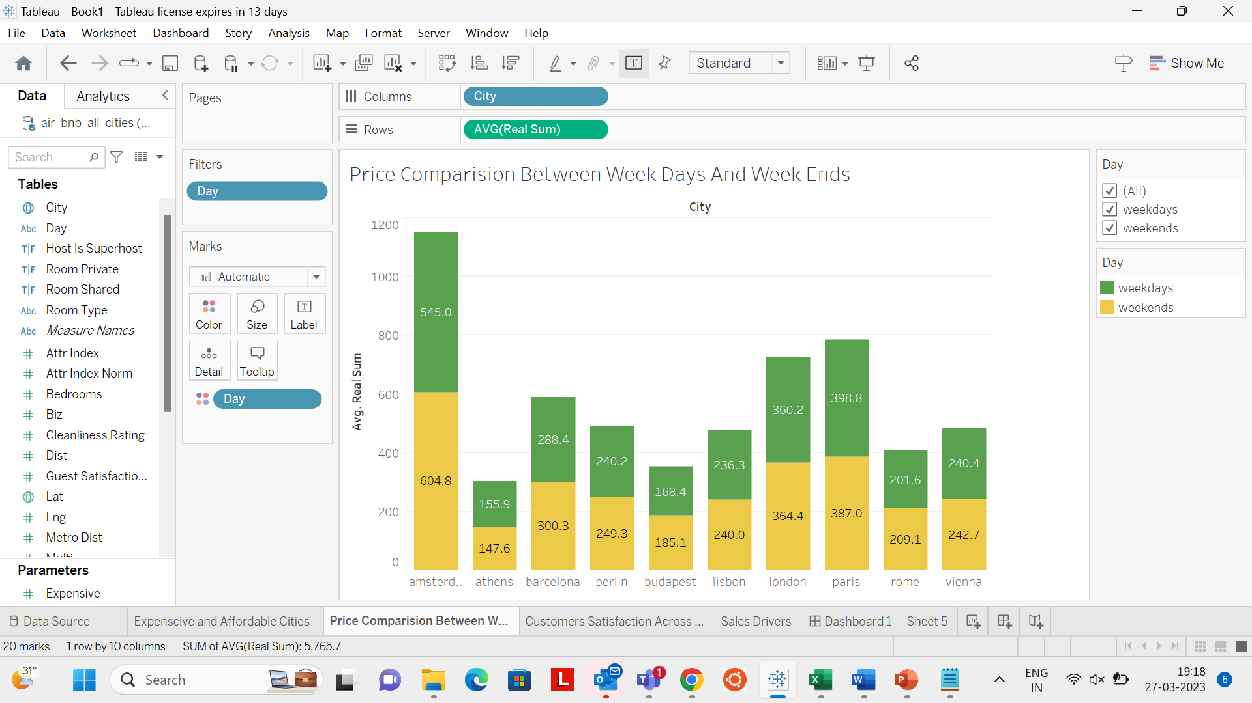For example, Amsterdam has an average weekday price of $545 per room, but that jumps to $604 on weekends. On the other hand, Athens has an average weekday price of $155 per room and $147 on weekends, making it an affordable choice no matter when you visit.

Other cities with cheaper weekday rates include Budapest, Lisbon, and Rome, while Vienna has consistently low prices throughout the week.

Of course, some cities like London and Paris have relatively stable prices regardless of the day of the week, so it's worth doing your research to find the best deals for your travel dates.

Use our data to plan your European getaway and find the perfect Airbnb accommodation for your budget and preferences.

The above analysis describe the how the average customer satisfaction of different rooms in different cities in various factors.

From the above data analysis we can find that how flexible is a room to different customers based on how it is convenient in different factors like the average distance of the metro for the rooms that are in particular cities and how affordable is the price of different rooms in different cities so and also what is the average capacity of all the rooms in a particular city.

Finally we can conclude that the Airbnb hosts can use these insights to optimize their pricing strategies and improve their customer experience based on the specific city and type of room they are offering. Hosts in Amsterdam could leverage the high demand for accommodations to charge a premium price for their listings, while hosts in Athens could attract more customers by offering more affordable rates. Hosts could also adjust their pricing strategies based on the day of the week and the type of room they offer to maximize their occupancy rates and revenue. In this way they can improve.